Agent-orchestrated SDLC: roles, responsibilities, and artifacts
Each phase of the lifecycle is owned by an autonomous agent. Artifacts — not conversations — are the handoff mechanism: every agent consumes upstream artifacts and produces downstream ones, so the pipeline is traceable end to end and each agent can be evaluated against the quality of what it emits.

Workflow overview
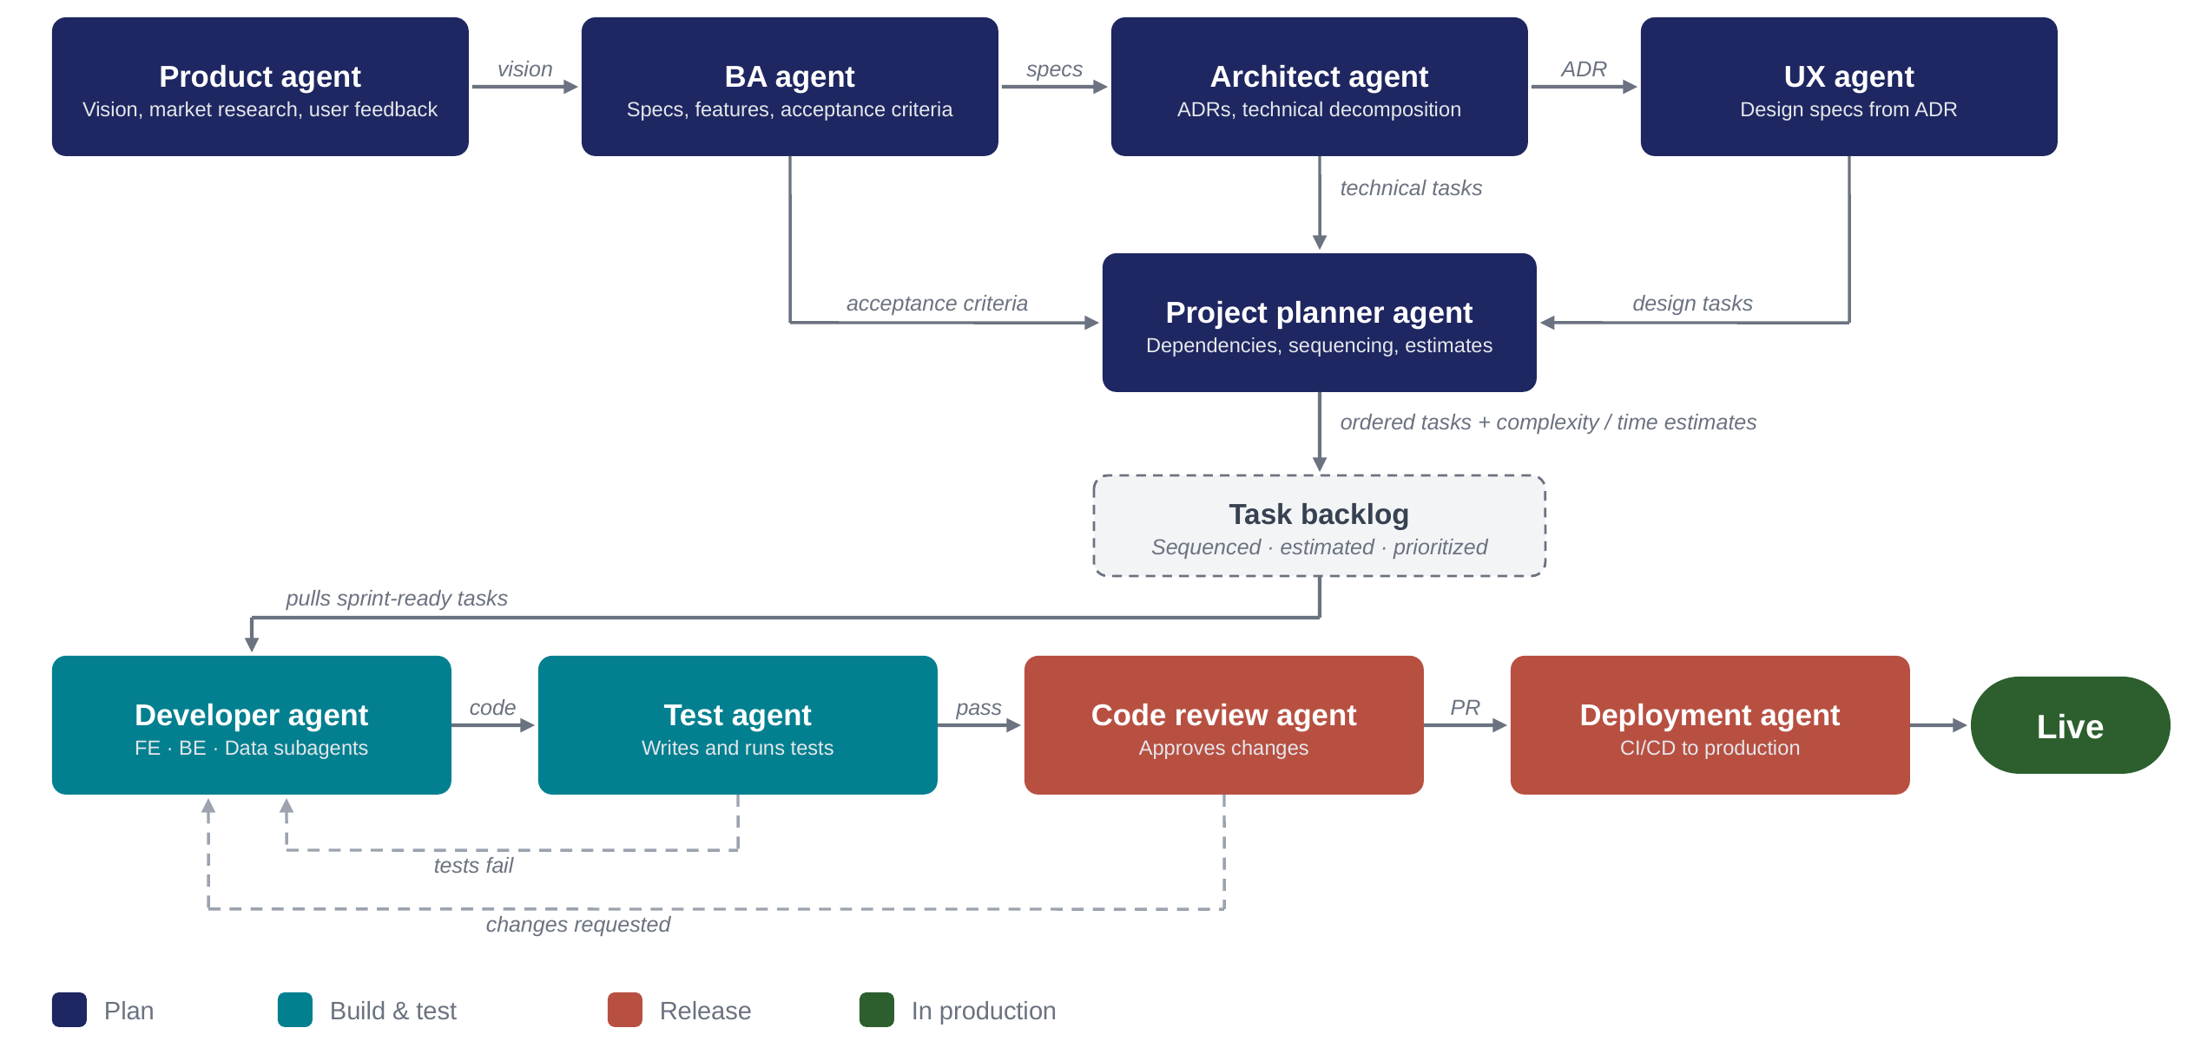
Solid arrows: artifact handoffs on the happy path. Dashed arrows: feedback loops returning work to the developer agent.

Planning phase
Product agent — the guardian of the why. Owns product envisioning, market research, competitive benchmarking, and the collection and synthesis of user feedback, keeping every downstream decision anchored to the project's goal. It consumes market signals, competitor analyses, and — once the product is live — real usage feedback. It hands over a product vision and goals artifact: problem statement, target users, success metrics, and strategic priorities.
BA agent — the guardian of the what. Translates the vision into concrete, testable requirements: functional specs, feature definitions, user stories, and acceptance criteria. Where the product agent says “reduce onboarding drop-off,” the BA agent says “the signup flow shall complete in three steps, with SSO support, verified by these criteria.” It produces the specs handed to the architect and the acceptance criteria handed to the project planner — which later become the contract the test agent verifies against.
Architect agent — the guardian of the how. Consumes the specs and makes the structural decisions: technology choices, system boundaries, integration patterns, non-functional requirements. Its artifacts are the ADRs (architecture decision records documenting each significant choice and its rationale, passed to the UX agent and kept as living documentation) and the technical decomposition — specs broken into implementable tasks with dependencies identified, passed to the project planner.
UX agent — the guardian of the experience. Works from the ADRs so designs respect real technical constraints rather than fighting them. Produces design specs: user flows, wireframes, component definitions, and interaction patterns. These become the design tasks handed to the project planner, ensuring design work is scheduled alongside — not after — the technical work it pairs with.
Project planner agent — the arbiter and sequencer. Receives three streams: acceptance criteria (BA), technical tasks (architect), and design tasks (UX). It merges them into one coherent plan: resolving cross-stream dependencies (a frontend task blocked by an API task blocked by a schema task), sequencing the work, and attaching a complexity and time estimate to every item. Its output is the ordered, estimated task list written into the task backlog.

The pivot artifact: task backlog
Not an agent but the single source of truth between planning and execution. Every item is sprint-ready: sequenced, estimated, dependency-aware, and traceable back to an acceptance criterion, an ADR, or a design spec. Planning agents write into it only through the planner; execution agents only pull from it. This one-door-in, one-door-out rule keeps the two halves of the pipeline decoupled.

Execution phase
Developer agent — the orchestrator of implementation. Pulls sprint-ready tasks and delegates to its specialized subagents — frontend, backend, and data — coordinating their work so the pieces integrate. It consumes tasks, design specs, and ADRs (as constraints); its artifact is code, delivered on feature branches. It is also the return address for both feedback loops: failed tests and requested review changes land back here.
Test agent — the verifier. Consumes the code plus the original acceptance criteria and writes and runs the test suite (unit, integration, and acceptance-level). Its artifact is the pass/fail result: failures loop back to the developer agent with diagnostic context; passes gate the work forward to review. Because it tests against the BA's acceptance criteria rather than the developer's interpretation, it catches drift between what was asked and what was built.

Release phase
Code review agent — the quality gate. Consumes passing code and reviews it for correctness, security, maintainability, and conformance to the ADRs. It produces either change requests (looped back to the developer agent as actionable comments) or an approved pull request — the artifact that certifies the change is ready to ship.
Deployment agent — the shipper. Consumes the approved PR and executes the CI/CD pipeline: build, artifact packaging, environment promotion, deployment to production, and post-deploy verification, with rollback as its safety artifact. Its output is the live release. Once live, telemetry and user feedback flow back to the product agent, closing the outer loop and making the lifecycle continuous rather than a one-way waterfall.

Summary: handoff matrix
Agent | Owns | Consumes | Produces / hands over
Product agent | Vision, market research, benchmarking, user feedback | Market signals, competitor analysis, production feedback | Product vision & goals → BA agent
BA agent | Specs, features, requirements | Vision & goals | Specs → Architect; acceptance criteria → Planner
Architect agent | Architecture, technology decisions | Specs | ADRs → UX agent; technical tasks → Planner
UX agent | User experience, design system | ADRs (constraints) | Design specs / design tasks → Planner
Project planner agent | Sequencing, dependencies, estimation | Acceptance criteria, technical tasks, design tasks | Ordered, estimated tasks → Task backlog
Task backlog (artifact) | Single source of truth for work | Planner output only | Sprint-ready tasks → Developer agent
Developer agent | Implementation via FE / BE / Data subagents | Tasks, design specs, ADRs; feedback loops | Code (feature branches) → Test agent
Test agent | Verification against acceptance criteria | Code + acceptance criteria | Pass → Review agent; fail → Developer agent
Code review agent | Quality, security, ADR conformance | Passing code | Approved PR → Deployment; change requests → Developer
Deployment agent | CI/CD, release, rollback | Approved PR | Live release → production

